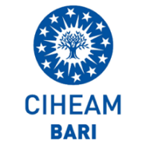
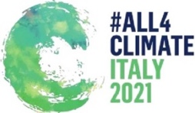
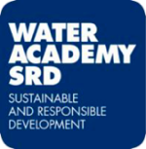
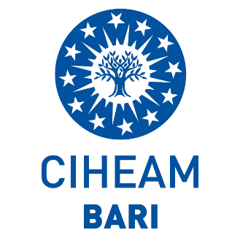
WATER ACADEMY SRD Foundation
and
CIHEAM Bari

In partnership with

Cordially invite you to the

COP26 Initiative “Youth 4 Climate”
on
“Water Security and Food Security nexus: the Challenge of Climate Change”

14th-15th September 2021 – Bari (Italy)

R.S.V.P.: segreteria@wasrd.org or iamdir@iamb.it
Abstract
The aim of the Event, organized by the Water Academy SRD Foundation and CIHEAM Bari Institute, in partnership with IRRITEC, is to focus on the importance to root and diffuse a New Culture of Water at the international level in the Didactic Curricula. This will strengthen the engagement of young generation to better comprehend and consequently face the severe changes impose by Climate Changes in Water Access and Water for Life policies when dealing with the strategic issue of the nexus Water Security/Food Security. The presence of relevant personalities from Multilateral Institutions, Research Centers, Universities and Private sector allows a fruitful and positive debate and confrontation on the urgent need to find appropriate solutions to tackle this epochal challenge. Considering that Agriculture is the human activity that consumes the highest percentage of fresh water, it represents the core of the defiance. As usual, Proceedings of the workshop will be jointly published by Water Academy SRD Foundation and CIHEAM Bari, in the Editorial Series “Dialogues around Water” for the benefit of those Scholars and Students that aim to investigate the most updated achievements on this subject.

